PHENIKAA UNIVERSITY
SCHOOL OF COMPUTING


COURSE MODULE: SOFTWARE ARCHITECTURE
PROJECT TITLE: BadNet - Badminton Social Network

Instructor: ThS. Vũ Quang Dũng
Group: Nguyễn Hoàng Thái Bảo (23010096)

Class: CSE703110-1-3-25(N01)

Ha Noi, June 17, 2026
Contents
List of Figures 2
Chapter 1: Project Overview 4
1.1 Problem Statement 4
1.2 Project Objectives 4
1.3 Project Scope 5
1.4 Technology Stack Overview 5
Chapter 2: Requirements Analysis (SRS) 6
2.1 Functional Requirements 6
2.2 Non-Functional Requirements 8
2.3 Use Case Diagram and Use Cases 10
2.4 Architecturally Significant Requirements 12
Chapter 3: Architecture and System Design (SDD) 12
3.1 Architectural Style Selection 12
3.2 C4 Model 13
3.3 Database Design 15
3.4 REST API and Route Design 16
3.5 UML Diagrams 18
3.6 Architecture Decision Records 21
3.7 UI Prototype and Screenshots 22
References 24

List of Figures
Figure 1.BadNet use case diagram 10
Figure 2.C4 Level 1 - System context diagram. 13
Figure 3.C4 Level 2 - Container diagram. 14
Figure 4. C4 Level 3 - Component diagram. 14
Figure 5. C4 Level 4 - Code diagram. 15
Figure 6. Database entity relationship diagram. 15
Figure 7. Domain class diagram. 18
Figure 8. Sequence diagram - registration and email verification. 18
Figure 9. Sequence diagram - challenge accepted and match created. 19
Figure 10. Sequence diagram - pool betting settlement. 19
Figure 11. Activity diagram - betting market lifecycle. 20
Figure 12. Activity diagram - match result confirmation and dispute. 20
Figure 13. Login screen screenshot. 22
Figure 14. Registration screen screenshot. 22
Figure 15. Public home screen screenshot. 23

Chapter 1: Project Overview

1.1 Problem Statement
BadNet is a web platform for badminton communities where players can post updates, find opponents, join teams, register for tournaments, manage match schedules and participate in virtual pool betting. In many amateur badminton clubs, match discovery, court coordination, team organization and result tracking are still handled through disconnected chat groups or spreadsheets. This makes it hard to verify match results, notify players reliably, and keep a transparent record of betting or virtual-point transactions.
The project addresses this gap by combining a player-facing social network with an operations-focused admin panel. The architecture emphasizes data integrity for betting and wallet transactions, real-time notification awareness, role-based moderation, and a consistent responsive interface for both light and dark mode.

1.2 Project Objectives
ID | Objective | Measurement
OBJ-01 | Provide at least eight player functions: authentication, posts, comments, notifications, challenges, matches, teams, tournaments and betting. | Implemented as Laravel routes and Blade/React views.
OBJ-02 | Provide an admin panel for users, roles, wallet balances, betting markets, tournaments, content moderation and audit logs. | Admin routes protected by auth and admin middleware.
OBJ-03 | Protect betting and wallet integrity using database transactions, row locks and ledger records. | BetService and WalletService use DB::transaction and lockForUpdate.
OBJ-04 | Document architecture with C4, ERD, UML, API design and ADRs. | Included in Chapters 2 and 3.
OBJ-05 | Prepare at least 30 functional test cases mapped to requirements. | Included in Chapter 5.

1.3 Project Scope
In scope: account registration with email verification, password reset, home feed, challenges, matches, teams, tournaments, pool betting, notifications, profile, admin players, admin betting, admin moderation, admin statistics and audit logging. Out of scope: native mobile applications, real payment gateways, official BWF data integration, production-grade anti-fraud machine learning and multi-tenant deployment.

1.4 Technology Stack Overview
Layer | Technology | Purpose
Backend | Laravel 9, PHP 8.1 | MVC routing, controllers, services, validation and Blade rendering.
Frontend | Blade, vanilla CSS, React, Vite | Server-rendered views and interactive player portal widgets.
Database | MySQL | Persistent storage for users, posts, matches, bets, teams, tournaments and ledgers.
Realtime-ready | Laravel events, Echo/Pusher compatible structure | Notification and pool movement events.
Testing | PHPUnit / Laravel test runner | Automated regression checks for key workflows.

Chapter 2: Requirements Analysis (SRS)

2.1 Functional Requirements
ID | Requirement | Priority
FR-01 | Users can register, verify email with a code, login, logout and reset password with a 15-minute token. | High
FR-02 | Users can create, like, comment, delete and view social posts. | High
FR-03 | Users can find opponents, create challenges, accept/reject invitations and create matches. | High
FR-04 | Users can create or join teams and view team members. | High
FR-05 | Team leaders and admins can add or remove team members. | High
FR-06 | Users can create, browse, view and join tournaments. | High
FR-07 | Tournament organizers and admins can add or remove participants. | High
FR-08 | Users can place virtual-point bets on eligible matches. | High
FR-09 | The system locks stakes immediately and records all wallet changes in a ledger. | High
FR-10 | Admins can approve, cancel, update or delete betting odds. | High
FR-11 | Admins can ban, delete, restore users and set roles including admin. | High
FR-12 | Admins can adjust user wallet balances with an audit reason. | High
FR-13 | Users receive categorized notifications with unread, pinned, mark-read and deep-link actions. | Medium
FR-14 | Admin statistics and betting charts display tooltip values on pointer movement. | Medium
FR-15 | The UI supports light and dark modes with shared CSS tokens. | Medium

2.2 Non-Functional Requirements
ID | Quality Attribute Scenario | Response Measure
NFR-01 Availability | When a regular user opens the home feed during normal operation, the system shall render the feed and right panel without requiring admin services. | Page responds within acceptable demo latency on localhost.
NFR-02 Integrity | When two users bet on the same match concurrently, the wallet balance and pool totals shall remain consistent. | Transactions use row locks and no negative balance is allowed.
NFR-03 Security | When an unauthenticated user accesses admin routes, the system redirects or blocks the request. | All admin routes are behind auth and admin middleware.
NFR-04 Usability | When users switch theme, core pages maintain readable contrast. | Light and dark modes use tokenized colors.
NFR-05 Maintainability | When adding a new betting operation, changes are localized to controller/service/model layers. | Business rules are centralized in BetService and WalletService.

2.3 Use Case Diagram and Use Cases
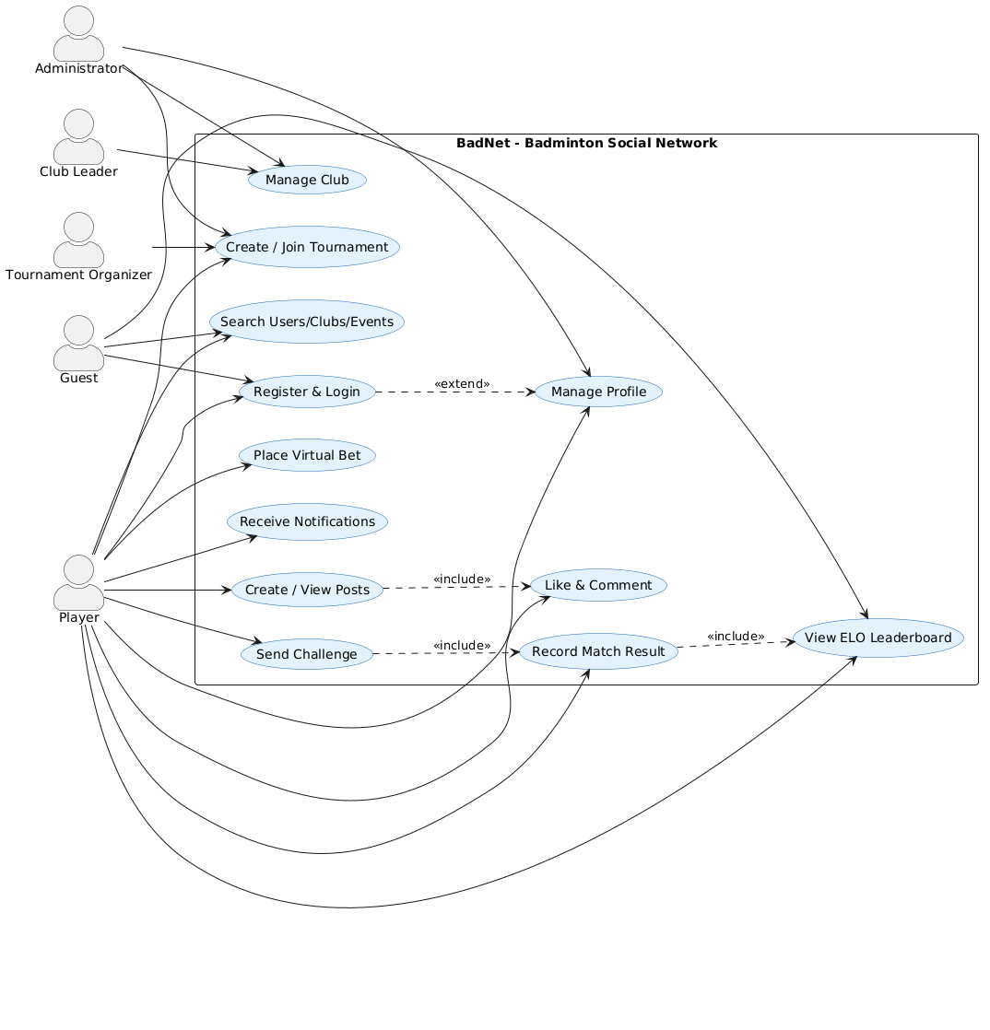
Figure 1.BadNet use case diagram
.

Use Case | Actor | Main Flow | Exception
Register and verify email | Guest | Submit registration form, receive verification code, enter code, access dashboard. | Invalid or expired code requires resend.
Create challenge | Player | Choose target player, skill level, type, court/time and send invitation. | Target rejects or match slot becomes unavailable.
Place bet | Player | Open bet slip, choose winner, enter stake, confirm, wallet stake is locked. | Insufficient balance disables confirmation.
Manage betting market | Admin | Review market, update odds, approve, suspend or cancel. | Completed market cannot accept new bets.
Moderate user/content | Admin | Search user/post, ban/delete/restore and record audit entry. | Admin cannot perform unauthorized action without role.

2.4 Architecturally Significant Requirements
ASR | Driver | Architectural Decision
ASR-01 Betting integrity | Wallet and betting operations must not corrupt balances. | Use DB transactions, lockForUpdate, WalletTransaction ledger and idempotent references.
ASR-02 Admin control | Moderation and financial actions require strong authorization. | Use role field, admin middleware, protected admin route group and audit log.
ASR-03 Notification clarity | Users must separate social, match, system and betting notices. | Notification model stores type/category/read/pinned/target_url.
ASR-04 UI consistency | Player and admin surfaces must share visual behavior. | CSS variables and shared fonts: Barlow Condensed, Inter, JetBrains Mono.

Chapter 3: Architecture and System Design (SDD)

3.1 Architectural Style Selection
BadNet uses a layered MVC architecture. Laravel routes dispatch HTTP requests to controllers, controllers validate input and delegate domain logic to services, services coordinate Eloquent models and database transactions, and Blade/React views render the user interface. This style matches the project scale and keeps business rules testable while still allowing fast UI iteration.

3.2 C4 Model
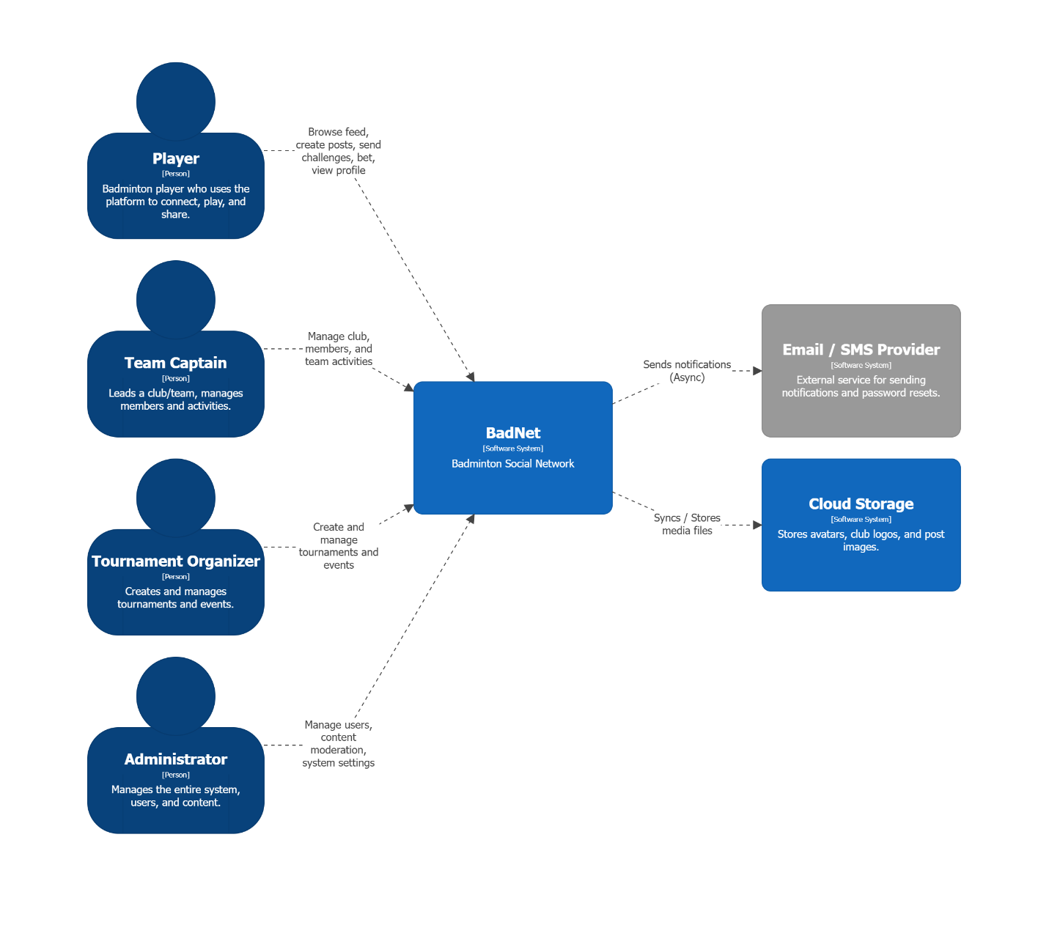
Figure 2.C4 Level 1 - System context diagram.
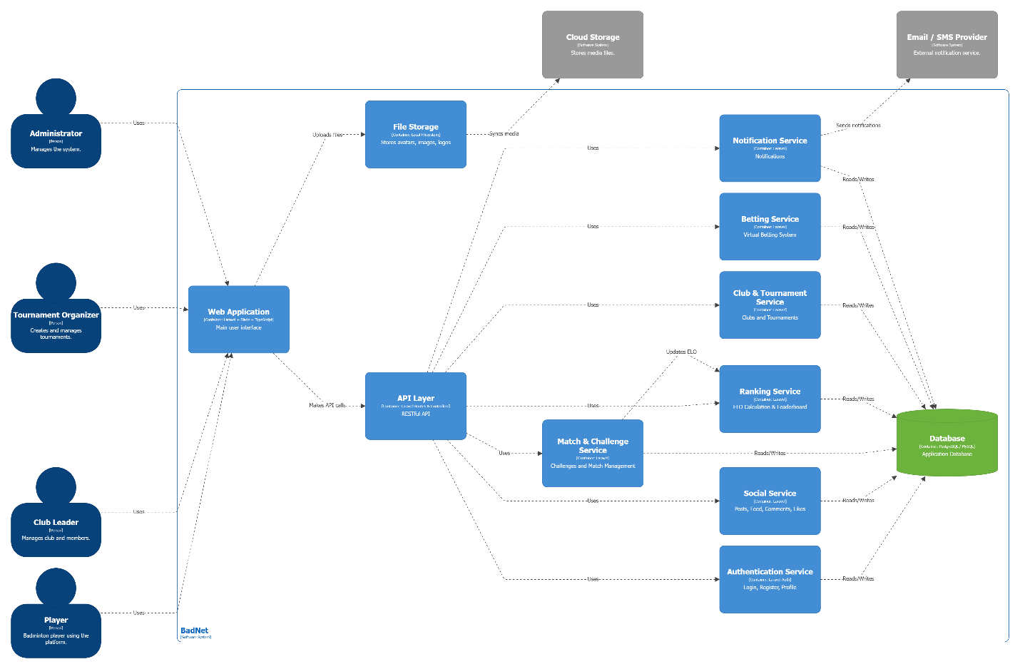
Figure 3.C4 Level 2 - Container diagram.

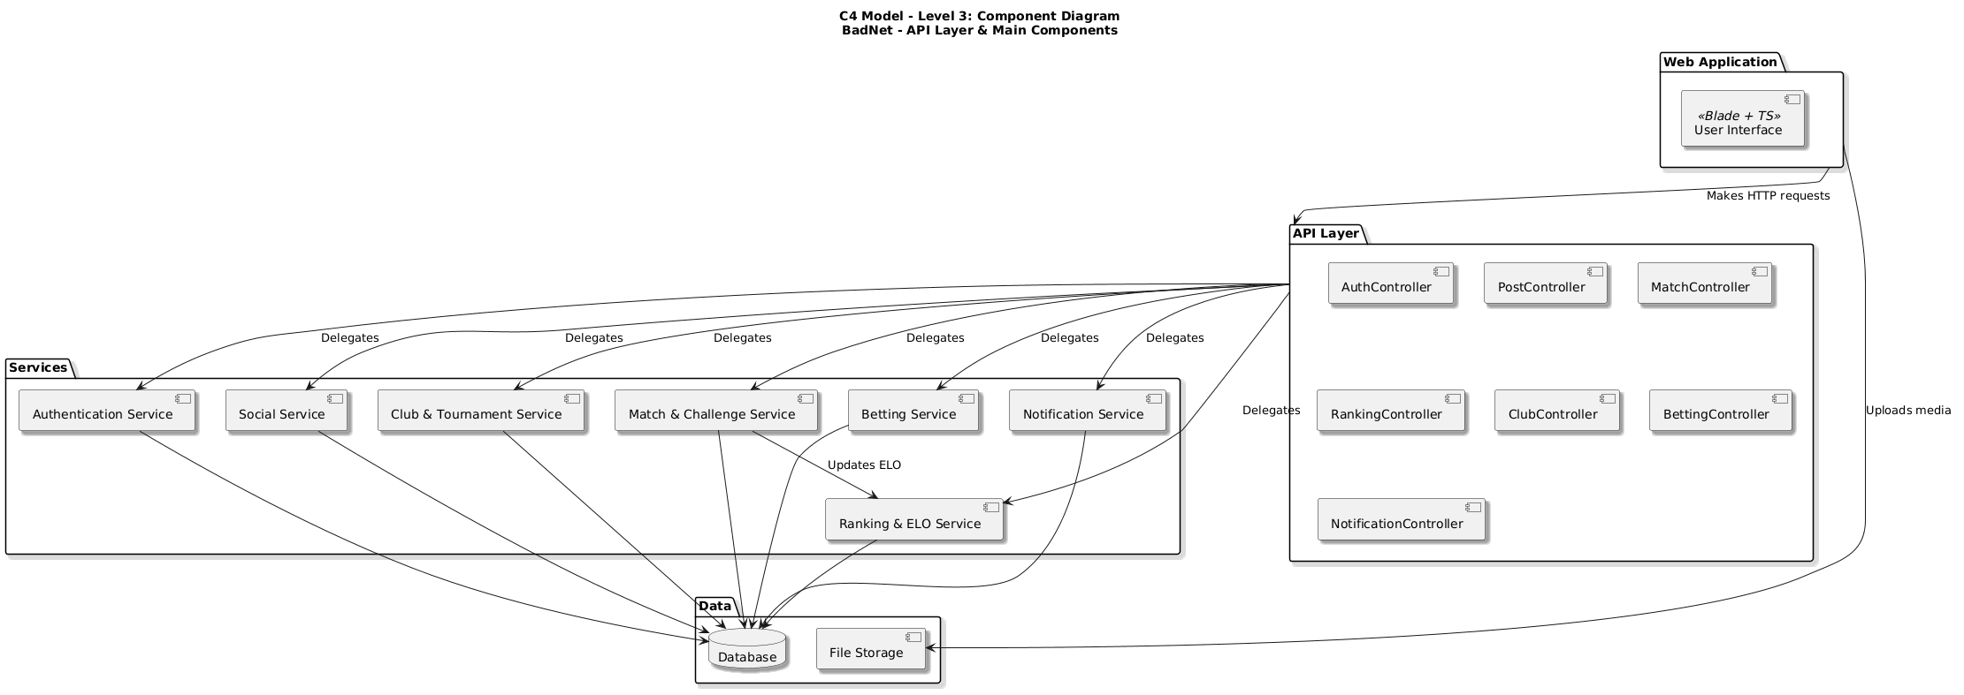
Figure 4. C4 Level 3 - Component diagram.
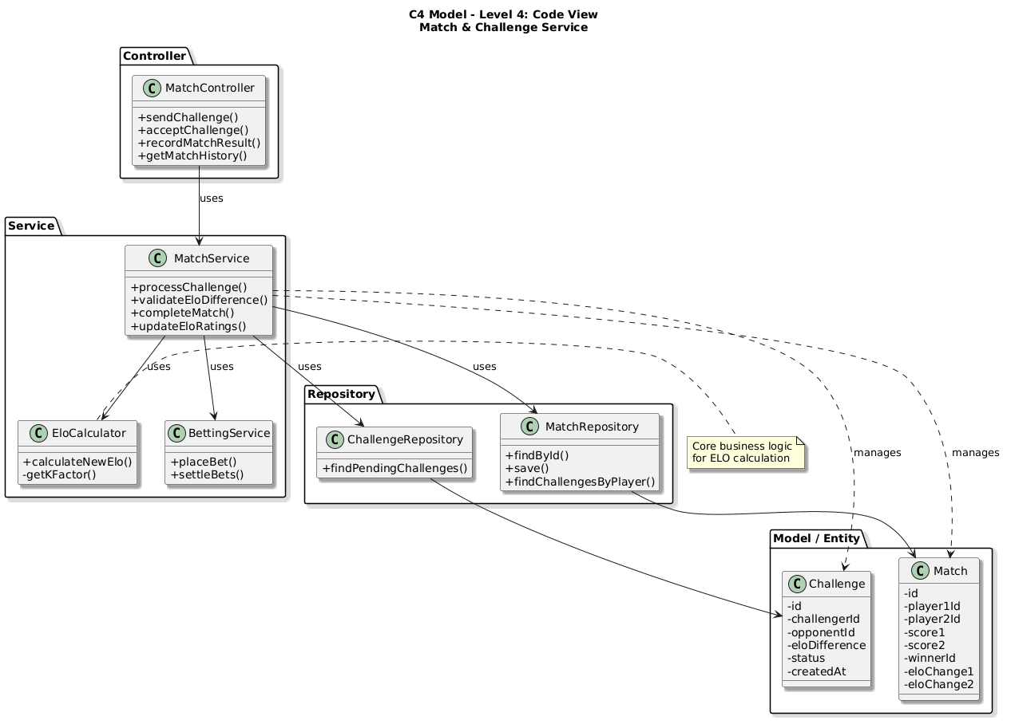
Figure 5. C4 Level 4 - Code diagram.

3.3 Database Design
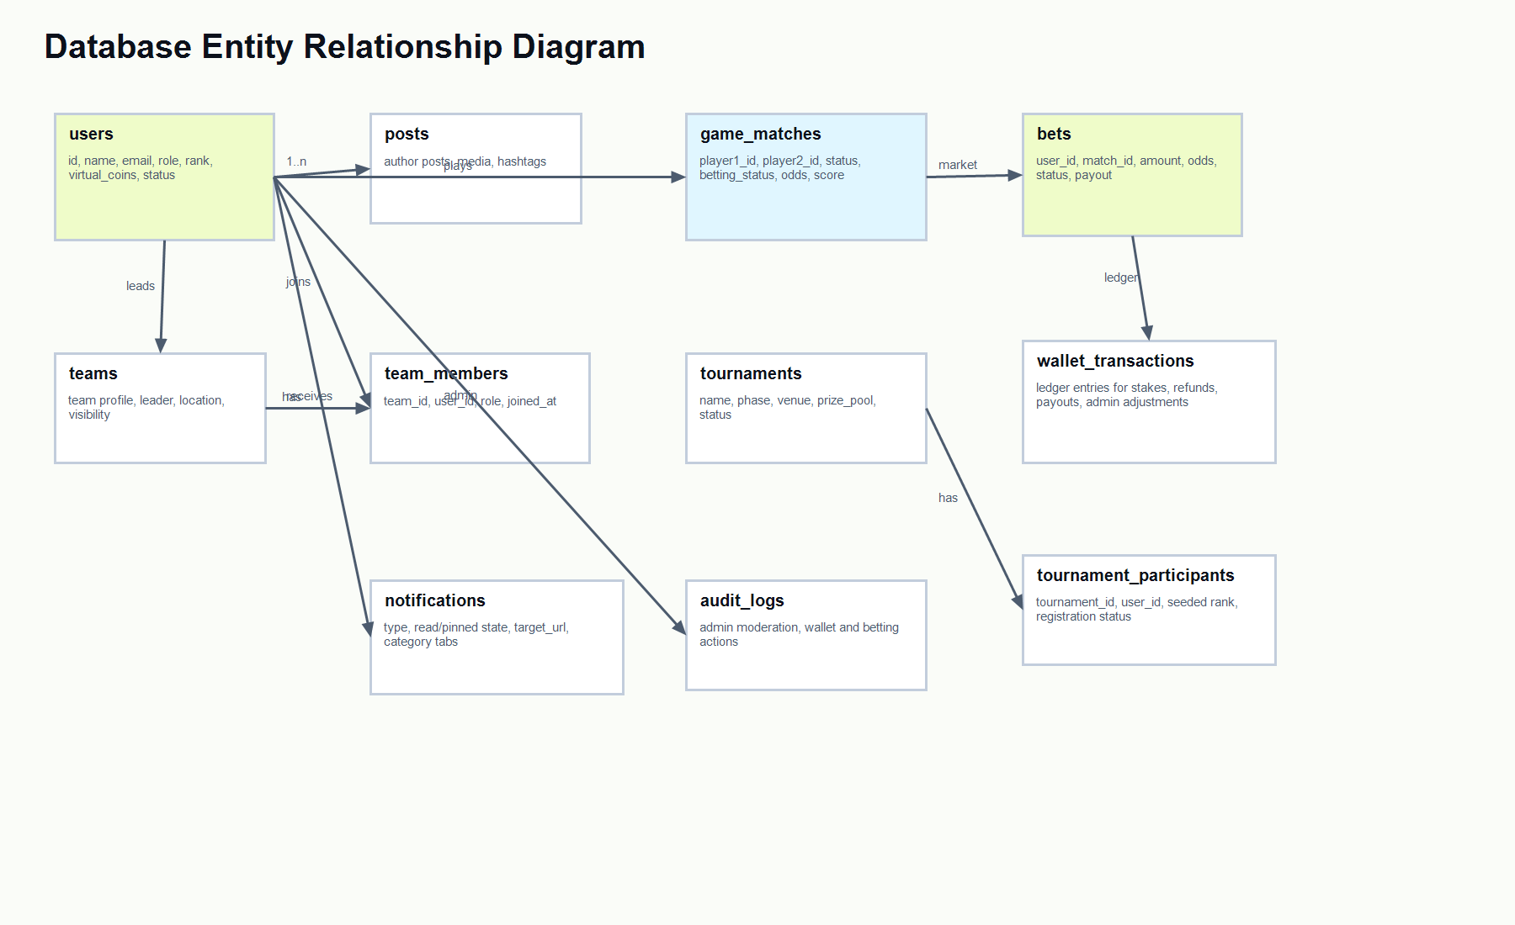
Figure 6. Database entity relationship diagram.
Entity | Responsibility
users | Stores identity, roles, rank, skill and virtual wallet balance.
game_matches | Stores match players, schedule, result, status and betting metadata.
bets | Stores individual predictions, stake, odds, status and payout state.
wallet_transactions | Append-only ledger for all wallet changes.
teams / team_members | Stores team ownership and membership.
tournaments / tournament_participants | Stores tournament registration and membership.
notifications | Stores social, system, match and betting notifications.

3.4 REST API and Route Design
Module | Representative Routes | Purpose
Authentication | GET /login, POST /login, GET /register, POST /register | Account access and email verification flow.
Matches | GET /matches, POST /matches, POST /matches/{match}/bet | Match discovery, creation, result and betting.
Teams | GET /teams, POST /teams/{team}/join, DELETE /teams/{team}/members/{user} | Team browsing and leader/admin membership control.
Tournaments | GET /tournaments, POST /tournaments/{tournament}/join | Tournament discovery and participant management.
Notifications | GET /notifications/recent, POST /notifications/mark-all-read, POST /notifications/{notification}/pin | Notification center actions.
Admin | GET /admin/players, POST /admin/players/{user}/wallet, POST /admin/betting/matches/{match}/odds | Operational control panel.

3.5 UML Diagrams
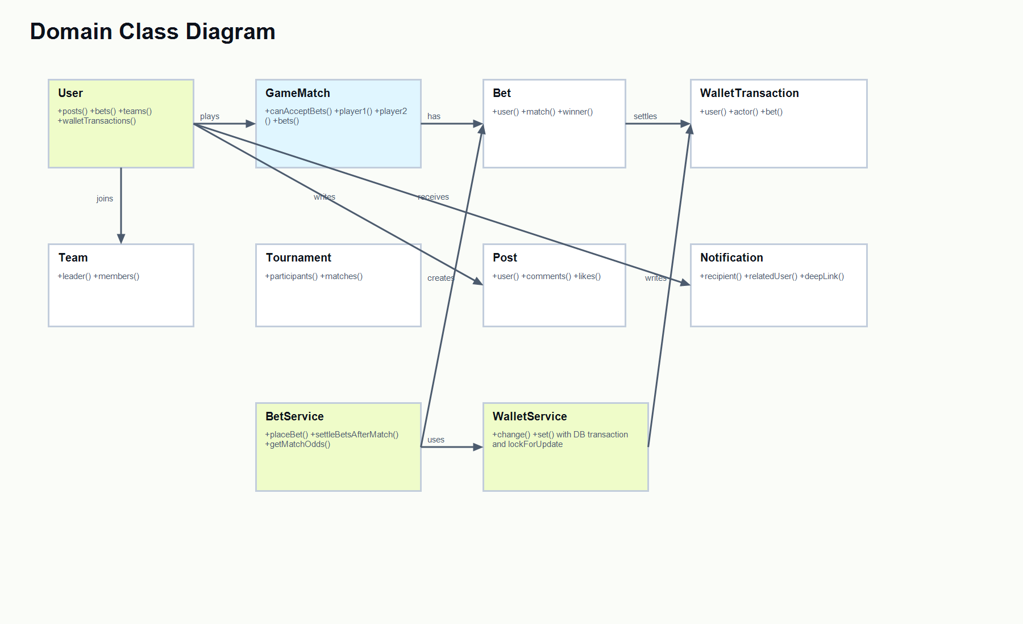
Figure 7. Domain class diagram.

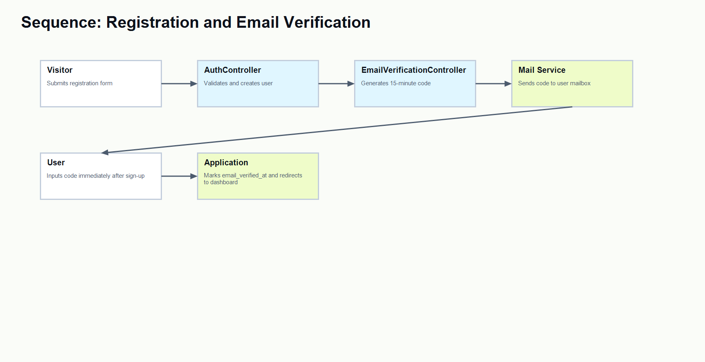
Figure 8. Sequence diagram - registration and email verification.
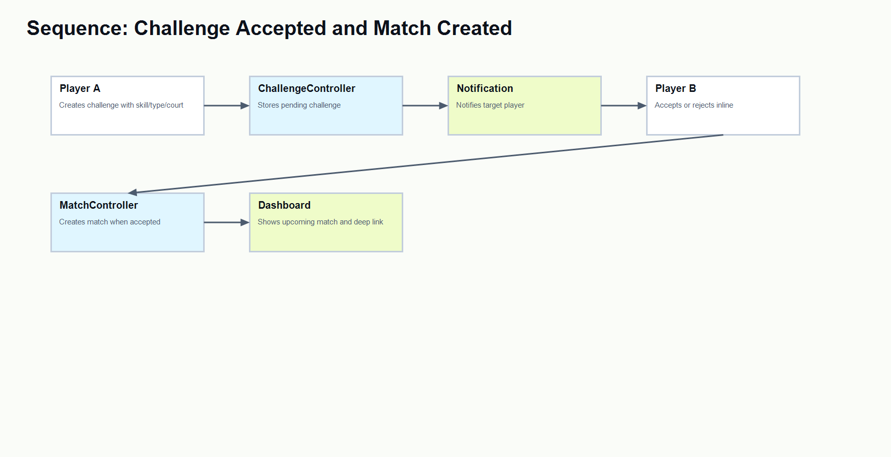
Figure 9. Sequence diagram - challenge accepted and match created.

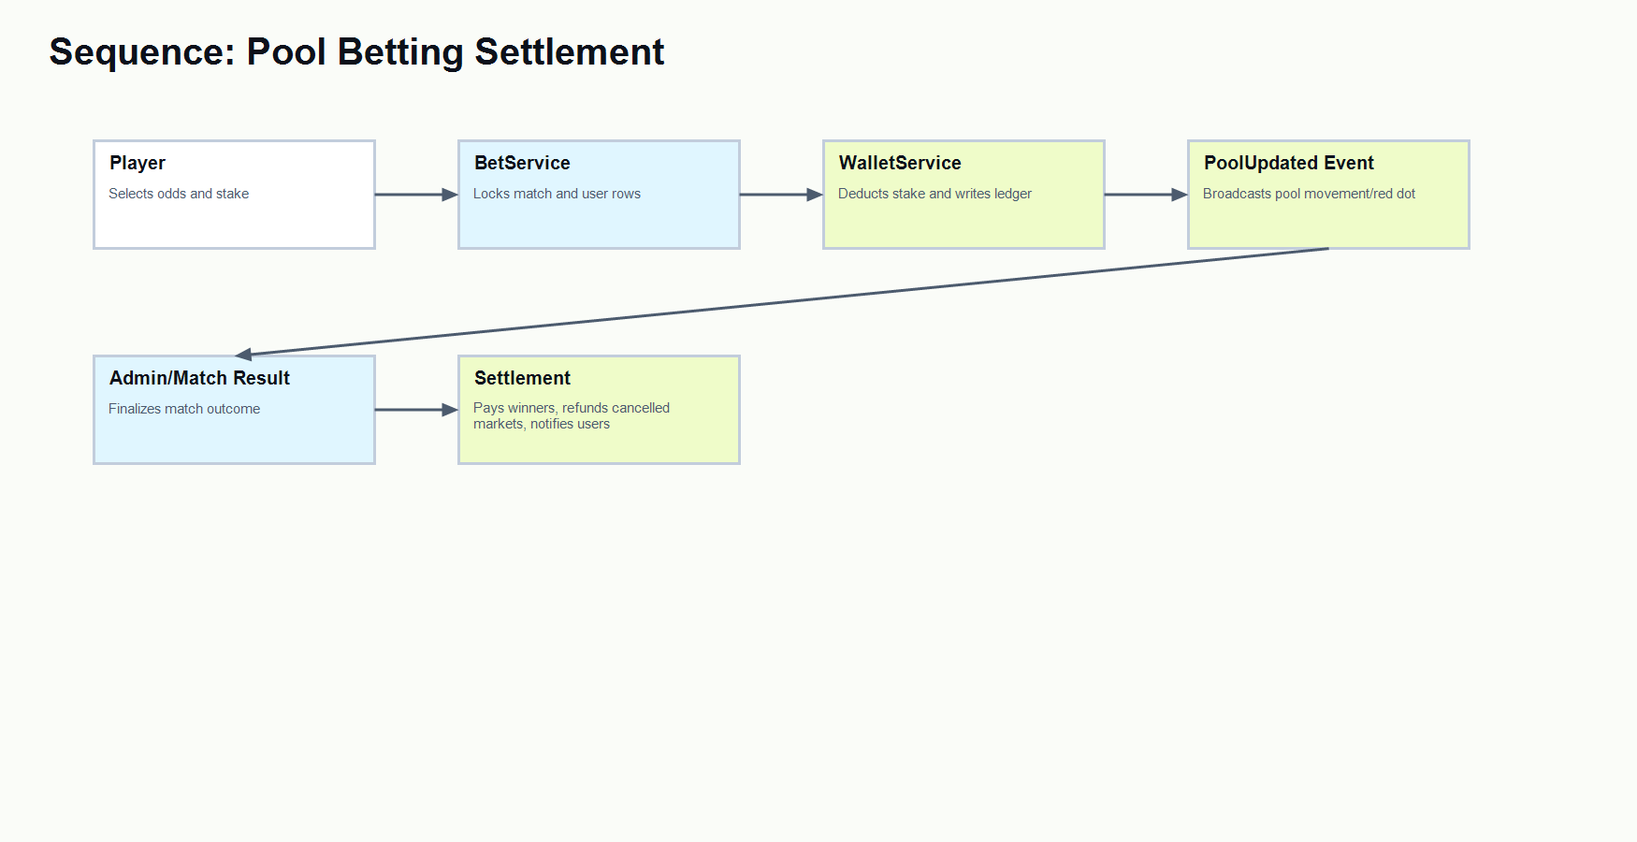
Figure 10. Sequence diagram - pool betting settlement.
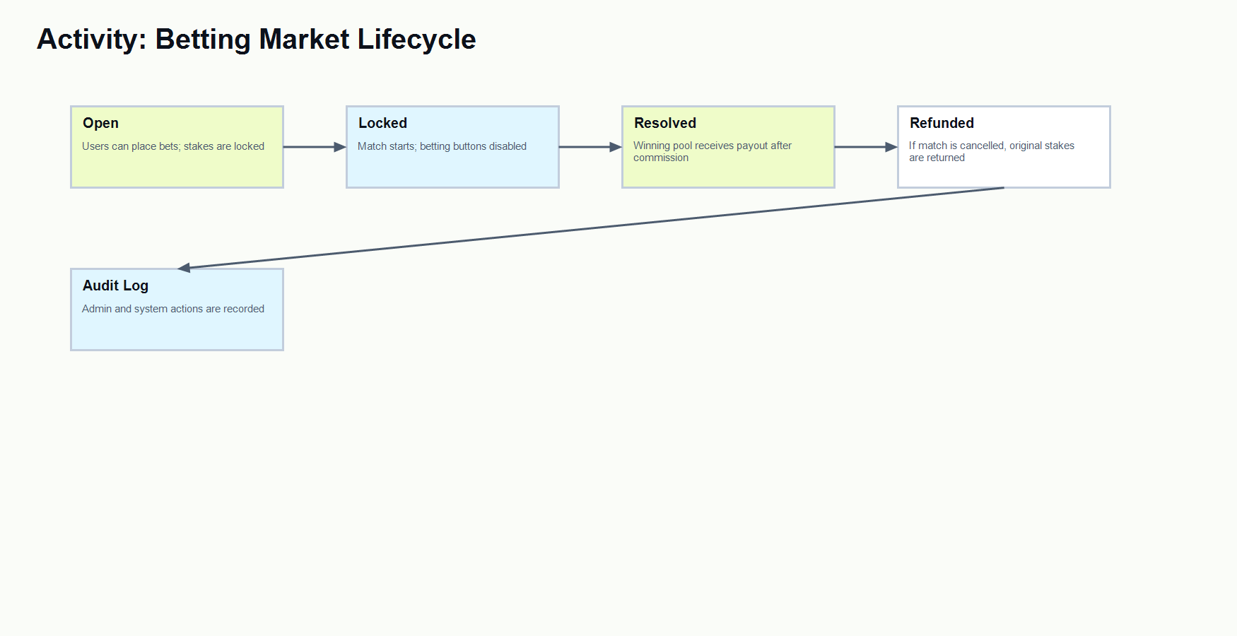
Figure 11. Activity diagram - betting market lifecycle.

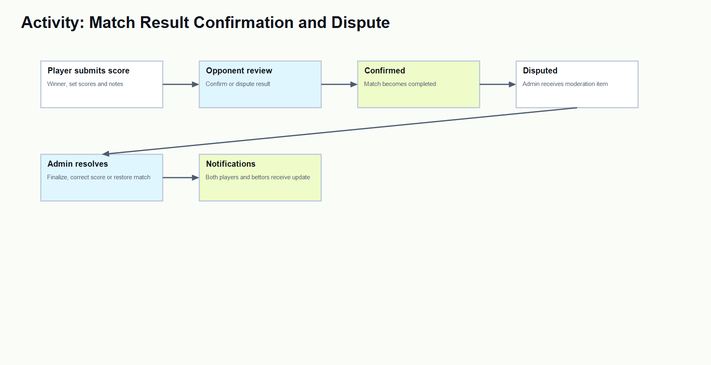
Figure 12. Activity diagram - match result confirmation and dispute.

3.6 Architecture Decision Records
ADR | Decision | Reason | Consequences
ADR-01 | Use Laravel MVC with Blade for core app. | The project needs fast CRUD, routing, auth and server-side forms. | Simple deployment and clear controller/service boundaries.
ADR-02 | Use service classes for betting and wallet logic. | Betting integrity is architecturally significant. | Rules are centralized and easier to test.
ADR-03 | Use pool betting instead of direct cash betting. | The academic demo must avoid real-money risk. | Virtual points can be locked, refunded and audited safely.
ADR-04 | Use CSS variables for theme and visual consistency. | Player and admin UI need shared tone and light/dark support. | Colors can be corrected globally without rewriting components.

3.7 UI Prototype and Screenshots
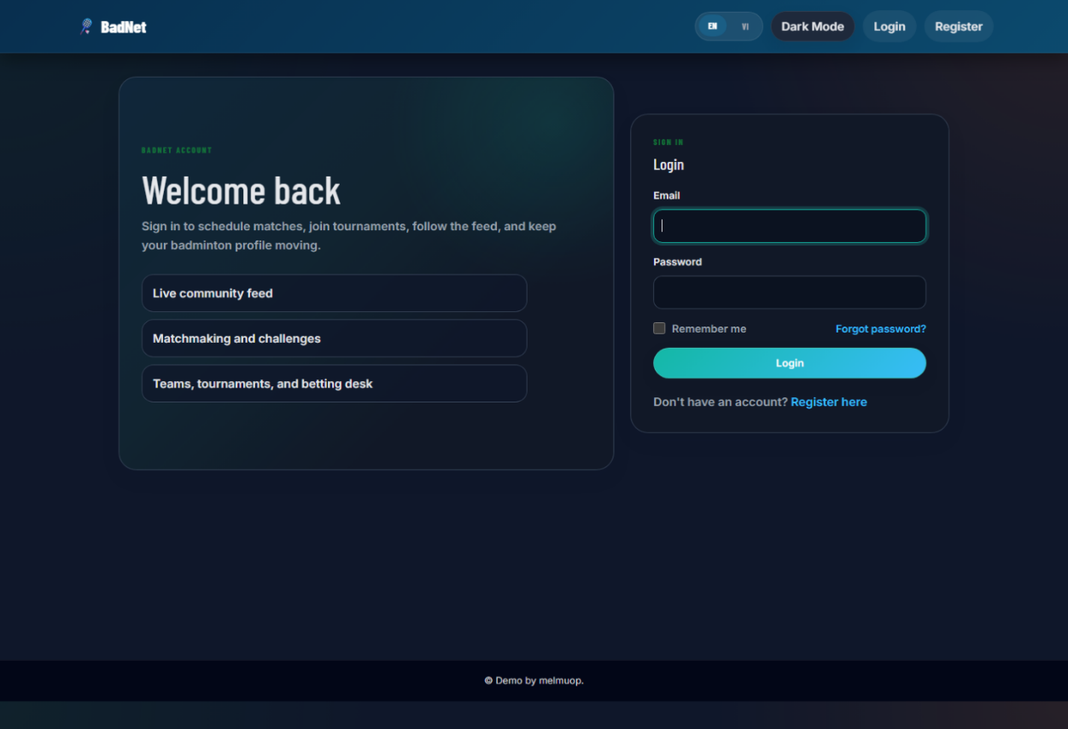
Figure 13. Login screen screenshot.
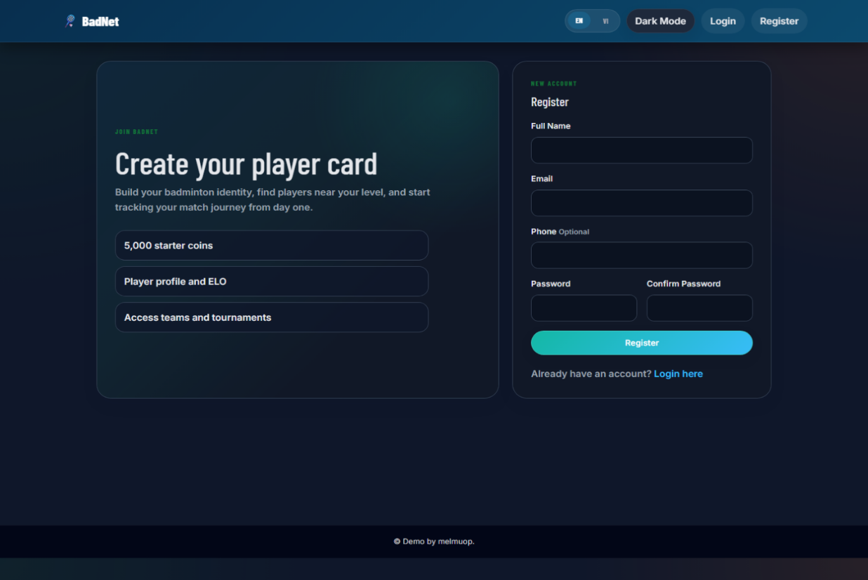
Figure 14. Registration screen screenshot.
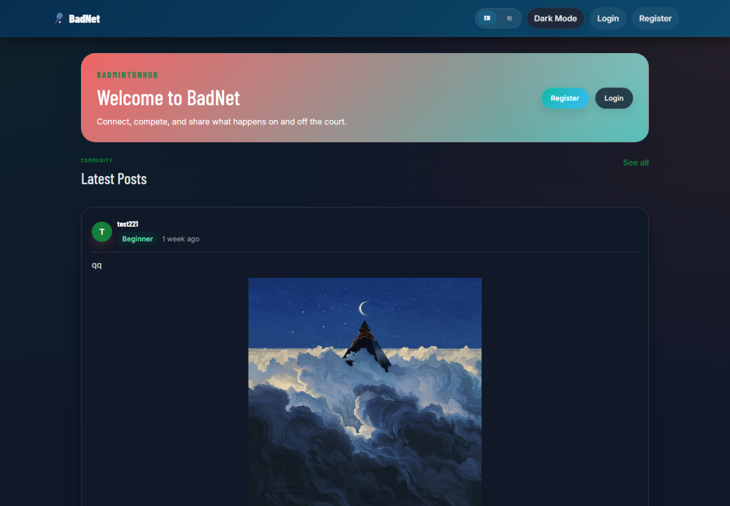
Figure 15. Public home screen screenshot.

References
[1] L. Bass, P. Clements, and R. Kazman, Software Architecture in Practice, 4th ed. Addison-Wesley, 2021.
[2] S. Brown, "The C4 model for visualising software architecture," c4model.com, accessed Jun. 16, 2026.
[3] R. T. Fielding, "Architectural Styles and the Design of Network-based Software Architectures," Doctoral dissertation, University of California, Irvine, 2000.
[4] Laravel, "Laravel Documentation," laravel.com/docs, accessed Jun. 16, 2026.
[5] PHP Group, "PHP Manual," php.net/manual, accessed Jun. 16, 2026.
[6] Oracle, "MySQL 8.0 Reference Manual," dev.mysql.com/doc, accessed Jun. 16, 2026.
[7] OWASP Foundation, "OWASP Top Ten," owasp.org, accessed Jun. 16, 2026.
[8] React Team, "React Documentation," react.dev, accessed Jun. 16, 2026.
[9] Vite Team, "Vite Guide," vite.dev/guide, accessed Jun. 16, 2026.
[10] Chart.js Contributors, "Chart.js Documentation," chartjs.org/docs, accessed Jun. 16, 2026.
[11] Microsoft, "Threat Modeling Tool and Security Development Lifecycle Guidance," microsoft.com/security, accessed Jun. 16, 2026.
[12] Martin Fowler, "Patterns of Enterprise Application Architecture," Addison-Wesley, 2002.

